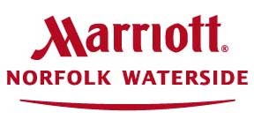

Vendor Information

Shipping to the Hotel:
Name of Guest Recipient
c/o Norfolk Waterside Marriott
235 East Main Street
Norfolk, VA 23510

Group Name:
Arrival Date:
Package # __of __

Materials will not be accepted more than 3 business days prior to the event and 3 days past the event.
Packages will be held in the Shipping & Receiving Room

Loading and Unloading:
- All unloading and loading must be done through the main loading dock off of Atlantic Street.
- Vehicles may not be parked in the loading dock except for loading and unloading only. (NO PARKING)
- Vendors must check in with Security Personnel located next to the Loading Dock
- Keys must be left with Security Personnel during loading/unloading.

Prohibited Items and Practices
- No Glitter or confetti of any kind
- No weapons may be displayed without prior written approval from the Norfolk Marriott Waterside Hotel
- Vehicles must not remain parked in the loading dock
- No preparation or service of food without prior written approval from the Norfolk Marriott Waterside Hotel
- Banners and signs may not be hung on the walls or from the ceiling

Information on Shipping from the Hotel:
- Boxes must be taped and shipping-ready
- All necessary return shipping labels should be brought by exhibitor
- Hotel Front Desk has a limited supply of labels for select carriers only
- Leave all shipping ready boxes in ballroom for hotel staff to take to loading dock
The hotel is not responsible for any lost or stolen items. Vendors exhibit at their own risk.

