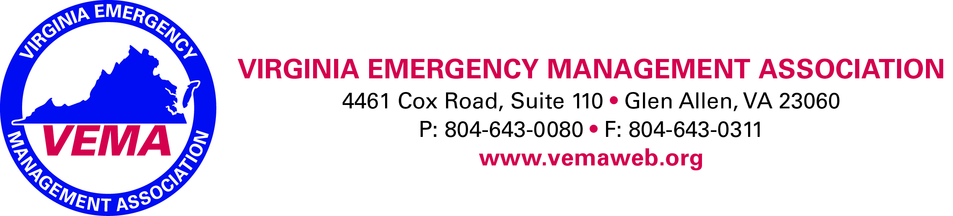

Minutes of the VEMA Board of Directors meeting held via GoToWebinar on June 6th at 12:00 noon.
In attendance were the following members: Ruth Reich, Maribel Street, Bobby Gelormine, Robert Foresman, Jennifer Maul, Walter English, Will Flagler, David Eagle, Allison Farole, Sherri Laffoon, Nick Drauschak, Stephen Owen, and Bo Keeney (Executive Director - Ex-Officio).
The meeting was called to order at 12:10 pm by Robert Foresman who presided. The purpose of this meeting was to address and approve the VEMA 2019-2020 general fund operating budget.
VEMA Treasurer, Will Flagler, provided an overview of the VEMA draft budget. He noted that the budget was developed by staff and presented to the VEMA Treasurer for comment/alternation. Staff originally includes all budget funding request in their initial draft. After presentation to the Treasurer the VEMA budget was presented to the VEMA Executive Board of Directors for their review and alteration. The VEMA Executive Board altered the draft budget, approved it and then presented a final version to the entire VEMA Board of Directors for approval.
Motion English/Gelormine to approve the 2019-2020 operating budget as presented, noting the following items have been adjusted and/or not funded for 2019-2020:
- Lowered the Legislative Committee allocation to $26,000. Activities are restricted to lobbying activities and no research at this time.
- VEMA will not utilize an association app for 2020 VEMS.
- VEMA reduced the scholarship funding request to $3,925 (in line with 2019’s award).
- VEMA will reduce VEMS Door Prizes to $500.
- VEMA will not utilize VEMS shirts for committee members, Thank you Cards, nor a VIP Dinner
- VEMA will not use Smartsheet for VEMS 2020.
- VEMA will reduce the funding for a registration bag item to $500
- VEMA will limit the Scholarship Outing cost to $10,675.
- VEMA will not fund challenge coins for the IHE caucus.
Motions passed unanimously.

The meeting was adjourned at 12:27 pm.

Respectfully Submitted,

Robert Gelormine
VEMA Secretary

